Fake News Detection System

Final Year Project

2019-2023 [Font size 16, bold, times new roman]

A project submitted in partial fulfillment of the degree of

BS in Computer Science



Department of Computer Science

Faculty of Computing & Artificial Intelligence (FCAI)

Air University, Islamabad

|  |  |  |  |  |  |
| --- | --- | --- | --- | --- | --- |
| Type (Nature of project) | | | [ ] Development [ ✓ ] Research | | |
| Area of specialization | | | [ ] WebApp [ ] Mobile App  [ ✓ ] AI based [ ] Embedded System | | |
| FYP ID | | |  | | |
| **Project Group Members** | | | | | |
| Sr.# | Reg. # | Student Name | | Email ID | *Signature |
| (i) | 180978 | Maryam Munir | | 180978@Students.au.edu.pk |  |
| (ii) | 181030 | Qurat ul Ain | | 181030@Students.au.edu.pk |  |
| (iii) |  |  | |  |  |

*The candidates confirm that the work submitted is their own and appropriate credit has been given where reference has been made to work of others

# Plagiarism Certificate

This is to certify that, I ______Maryam Munir_______ S/D of _________Muhammad Munir________, group leader of FYP under registration no ___180978___________________________at Computer Sciences Department, Air University. I declare that my FYP report is checked by my supervisor.

Date:_____________ Name of Group Leader: Maryam Munir______________ Signature: _______________

Name of Supervisor: Mr. Shoaib Malik Co-Supervisor: Mr. XYZ

Designation: Lecturer Designation: Associate Professor

Signature: ________________ Signature: _________________

HoD: Dr. Mehdi Hassan

Signature: _______________

**Title:Fake News Detection System**

**Change Record**

|  |  |  |  |  |
| --- | --- | --- | --- | --- |
| **Author(s)** | **Version** | **Date** | **Notes** | **Supervisor’s Signature** |
|  | 1.0 |  | <Original Draft> |  |
|  |  |  | <Changes Based on Feedback from Supervisor> |  |
|  |  |  | <Changes Based on Feedback From Faculty> |  |
|  |  |  | <Added Project Plan> |  |
|  |  |  | <Changes Based on Feedback from Supervisor> |  |
|  |  |  |  |  |
|  |  |  |  |  |
|  |  |  |  |  |
|  |  |  |  |  |
|  |  |  |  |  |

**APPROVAL**

|  |  |  |
| --- | --- | --- |
| **Project Supervisor** | | |
| Name:______________________________ | |  | | |
| Date:_______________________________ | | Signature:_________________________ | | |
| **Project Manager** | | | |
| Date:_______________________________ | Signature:__________________________ | | |

|  |  |
| --- | --- |
| **Chair Department** | |
|  |  |
| Date:_______________________________ | Signature:__________________________ |

# Dedication

*This work is dedicated to my . . . . . .*

# Acknowledgements

I am really thankful to my supervisor/university/friend who has . . . . . . . . . .

Table of Contents

Dedications ii

Declaration of Originality iii

Copyrights Statement iv

Table of Contents v

List of Figures viii

List of Tables ix

Abstract x

List of Publications and Patents xi

List of Abbreviations and Symbols xii

Glossary xiii

Chapter 1. Introduction 1

1.1. Background [16pt, Bold, Times new Roman] 1

1.2. Motivations and Challenges 1

1.3. Goals and Objectives 1

1.4. Project Plan 1

1.4.1. Work Breakdown Structure 1

1.4.2. Roles & Responsibility Matrix 1

1.4.3. Gantt Chart 1

1.5. Report Outline 1

Chapter 2. Literature Review 2

2.1 First Heading 2

2.1.1 Example of Subheading Styles 3

2.1.2 Another Subheading Styles Example 4

2.1.3 Subheading styles 4

2.2 Formatting of Equations 5

2.3 Use of Referencing styles 5

Chapter 3. Software Requirement Specifications 6

3.1 Introduction 6

3.1.1 Purpose [14pt, Times new Roman, Bold] 6

3.1.2 Document Conventions 6

3.1.3 Intended Audience and Reading Suggestions 6

3.1.4 Product Scope 6

3.2 Overall Description 7

3.2.1 Product Perspective 7

3.2.2 User Classes and Characteristics 7

3.2.3 Operating Environment 7

3.2.4 Design and Implementation Constraints 7

3.2.5 Assumptions and Dependencies 8

3.3 External Interface Requirements 8

3.3.1 User Interfaces 8

3.3.2 Hardware Interfaces 8

3.3.3 Software Interfaces 8

3.3.4 Communications Interfaces 9

3.4 System Features 9

3.4.1 System Feature 1 9

3.4.2 System Feature 2 (and so on) 10

3.5 Nonfunctional Requirements 10

3.5.1 Performance Requirements 10

3.5.2 Safety Requirements 11

3.5.3 Security Requirements 11

3.5.4 Usability Requirements 11

3.5.5 Reliability Requirements 11

3.5.6 Maintainability/Supportability Requirements 11

3.5.7 Portability Requirements 11

3.5.8 Efficiency Requirements 11

3.6 Domain Requirements 11

Chapter 4. Use Case Analysis 12

4.1 Use Case Model 12

4.2 Use Cases Description 13

*4.2.1* User Login Function 13

Chapter 5. Proposed Approach 15

5.1 Data Set Exploration 15

5.2 Data Augmentation and Pre-Processing 15

Chapter 6. Business Plan 16

6.1 Business Description 16

6.2 Market Analysis & Strategy 16

6.3 Competitive Analysis 16

6.4 Products/Services Description 16

6.5 SWOT Analysis 16

Appendix A: Information / Promotional Material 17

Chapter 7. Conclusion 18

References 19

Microsoft Word Tutorial - Remove These Page 21

FYP DEFENSE 22

List of Figures

Figure ‎2‑1 This is an example figure of a cow. Source: Microsoft Clip Art Directory (for illustration only). 5

List of Tables

Table 1 This is an example table. 6

Abstract

Lorem ipsum dolor sit amet, consectetuer adipiscing elit. Maecenas porttitor congue massa. Fusce posuere, magna sed pulvinar ultricies, purus lectus malesuada libero, sit amet commodo magna eros quis urna. Nunc viverra imperdiet enim. Fusce est. Vivamus a tellus.

Pellentesque habitant morbi tristique senectus et netus et malesuada fames ac turpis egestas. Proin pharetra nonummy pede. Mauris et orci.

Lorem ipsum dolor sit amet, consectetuer adipiscing elit. Maecenas porttitor congue massa. Fusce posuere, magna sed pulvinar ultricies, purus lectus malesuada libero, sit amet commodo magna eros quis urna. Nunc viverra imperdiet enim. Fusce est. Vivamus a tellus.

Pellentesque habitant morbi tristique senectus et netus et malesuada fames ac turpis egestas. Proin pharetra nonummy pede. Mauris et orci.

Pellentesque habitant morbi tristique senectus et netus et malesuada fames ac turpis egestas. Proin pharetra nonummy pede. Mauris et orci. Lorem ipsum dolor sit amet, consectetuer adipiscing elit. Maecenas porttitor congue massa. Fusce posuere, magna sed pulvinar ultricies, purus lectus malesuada libero, sit amet commodo magna eros quis urna.

Nunc viverra imperdiet enim. Fusce est. Vivamus a tellus.Pellentesque habitant morbi tristique senectus et netus et malesuada fames ac turpis egestas. Proin pharetra nonummy pede. Mauris et orci.

Pellentesque habitant morbi tristique senectus 000000000000000000000000et netus et malesuada fames ac turpis egestas. Proin pharetra nonummy pede. Mauris et orci. Lorem ipsum dolor sit amet, consectetuer adipiscing elit. Maecenas porttitor congue massa. Fusce posuere, magna sed pulvinar ultricies, purus lectus malesuada libero, sit amet commodo magna eros

List of Publications and Patents

**Journal Publications**

* J. Smith, “Publishing in Biology,” J. Bioinformatics Educ., vol. 1, no. 1, pp. 1–7, 2013.
* J. Smith, “Not Publishing in Biology,” J. Bioinformatics Educ., vol. 1, no. 1, pp. 1–7, 2014.

**Conference Publications**

* J. Smith, “Still publishing in Biology?,” in Proceedings of the 2013 European Conference on Bioinformatics Education, Berlin, Heidelberg, 2013, pp. 146–161.

List of Abbreviations and Symbols

|  |  |
| --- | --- |
| **LID** | Lorem ipsum dolor |
| **SAC** | sit amet consectetuer |
| **AE** | adipiscing elit |

Glossary

|  |  |
| --- | --- |
| **Lorem** | Lorem ipsum dolor |
| **Ipsum** | Dit amet consectetuer |
| **Genome** | Adipiscing elit |

1. Introduction

[Paragraph Text 12 pt, Times New Roman, 1.5 Line Spacing, Justified]

[*Between 4 to 8 lines describe what is this chapter all about*]

In this chapter, we are going to discuss about the introduction of our projet ie fake news detection. We will discuss about different modules of our project here, most probably its litertaure review. About how we started and what was the motivation behind doing this particular project, its goals and achievments , and also the challenges. We will discuss them one by one here.

## Background [16pt, Bold, Times new Roman]

[Paragraph Text 12 pt, Times New Roman, 1.5 Line Spacing, Justified]

News currently spreads rapidly through the internet. Because fake news stories are designed to attract readers, they tend to spread faster. To solve this particular problem, we are working on the project to detect the fake news and develop/evaluate a stance detection system on the recently released Fake News Challenge Stage 1 (FNC-1) dataset introduced the benchmark FNC stage-1: stance detection task. To develop/evaluate fake news detection system based on existing approaches.

## Motivations and Challenges

[Paragraph Text 12 pt, Times New Roman, 1.5 Line Spacing, Justified]

The phenomenal growth in web information has nourished research endeavours for automatic fact checking, or fake news and/or misinformation detection.

## Goals and Objectives

[Paragraph Text 12 pt, Times New Roman, 1.5 Line Spacing, Justified]

Our goal is to reimplement the 3 HAN : A Deep Neural Network For Fake News Detection and do some modification and republish it.In this research paper, they are comparising header with the article text and identifying whether the text is relevant to the header or not. We are trying to compare the audio with the header text in youtube videos to detect them whether they are fake or not by using the same methodology. Following are some of the objectives:

**Research Objectives:**

In this case, our objective is to publish a research paper with a good accuracy and modification in the previous research paper.

**Academic Objectives:**

In this case, our objective is to continue this project in our MS studies.

**Commercial Objectives:**

In this case, our objective is to sell this fyp as we are also using this project in our entrepenurship project as our product and we are already looking for clients who are willing to collaborate with us on this research project.

## Project Plan

[Paragraph Text 12 pt, Times New Roman, 1.5 Line Spacing, Justified]

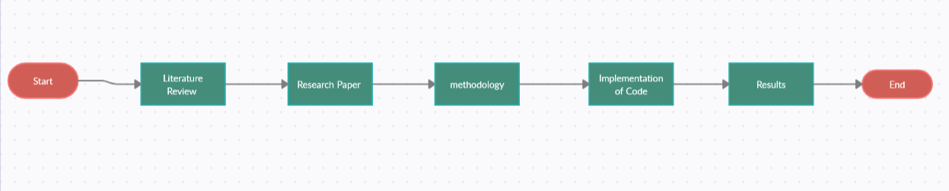

## Work Breakdown Structure

[Paragraph Text 12 pt, Times New Roman, 1.5 Line Spacing, Justified]

## Roles & Responsibility Matrix

[Paragraph Text 12 pt, Times New Roman, 1.5 Line Spacing, Justified]

## Gantt Chart

[Paragraph Text 12 pt, Times New Roman, 1.5 Line Spacing, Justified]

## Report Outline

[Paragraph Text 12 pt, Times New Roman, 1.5 Line Spacing, Justified]

1. Literature Review

Lorem ipsum dolor sit amet, consectetuer adipiscing elit. Maecenas porttitor congue massa. Fusce posuere, magna sed pulvinar ultricies, purus lectus malesuada libero, sit amet commodo magna eros quis urna. Nunc viverra imperdiet enim. Fusce est. Vivamus a tellus.

Pellentesque habitant morbi tristique senectus et netus et malesuada fames ac turpis egestas. Proin pharetra nonummy pede. Mauris et orci. Lorem ipsum dolor sit amet, consectetuer adipiscing elit. Maecenas porttitor congue massa. Fusce posuere, magna sed pulvinar ultricies, purus lectus malesuada libero, sit amet commodo magna eros quis urna. Nunc viverra imperdiet enim. Fusce est. Vivamus a tellus[1].

Pellentesque habitant morbi tristique senectus et netus et malesuada fames ac turpis egestas. Proin pharetra nonummy pede. Mauris et orci.

* 1. First Heading

Lorem ipsum dolor sit amet, consectetuer adipiscing elit. Maecenas porttitor congue massa. Fusce posuere, magna sed pulvinar ultricies, purus lectus malesuada libero, sit amet commodo magna eros quis urna. Nunc viverra imperdiet enim. Fusce est. Vivamus a tellus.

Pellentesque habitant morbi tristique senectus et netus et malesuada fames ac turpis egestas. Proin pharetra nonummy pede. Mauris et orci.

Lorem ipsum dolor sit amet, consectetuer adipiscing elit. Maecenas porttitor congue massa. Fusce posuere, magna sed pulvinar ultricies, purus lectus malesuada libero, sit amet commodo magna eros quis urna.

Nunc viverra imperdiet enim. Fusce est. Vivamus a tellus.

Pellentesque habitant morbi tristique senectus et netus et malesuada fames ac turpis egestas. Proin pharetra nonummy pede. Mauris et orci. Lorem ipsum dolor sit amet, consectetuer adipiscing elit. Maecenas porttitor congue massa. Fusce posuere, magna sed pulvinar ultricies, purus lectus malesuada libero, sit amet commodo magna eros quis urna. Nunc viverra imperdiet enim. Fusce est. Vivamus a tellus.

Pellentesque habitant morbi tristique senectus et netus et malesuada fames ac turpis egestas. Proin pharetra nonummy pede. Mauris et orci.

* + 1. Example of Subheading Styles

Lorem ipsum dolor sit amet, consectetuer adipiscing elit. Maecenas porttitor congue massa. Fusce posuere, magna sed pulvinar ultricies, purus lectus malesuada libero, sit amet commodo magna eros quis urna.Nunc viverra imperdiet enim. Fusce est. Vivamus a tellus.

Pellentesque habitant morbi tristique senectus et netus et malesuada fames ac turpis egestas. Proin pharetra nonummy pede. Mauris et orci.

#### Lower Level Heading Example

Lorem ipsum dolor sit amet, consectetuer adipiscing elit. Maecenas porttitor congue massa. Fusce posuere, magna sed pulvinar ultricies, purus lectus malesuada libero, sit amet commodo magna eros quis urna.

Nunc viverra imperdiet enim. Fusce est. Vivamus a tellus. Pellentesque habitant morbi tristique senectus et netus et malesuada fames ac turpis egestas. Proin pharetra nonummy pede. Mauris et orci.

C:\Program Files (x86)\Microsoft Office\MEDIA\CAGCAT10\j0149627.wmf

Figure ‎2‑1 This is an example figure of a cow. Source: Microsoft Clip Art Directory (for illustration only).

#### Another Lower Level Heading Example

Lorem ipsum dolor sit amet, consectetuer adipiscing elit. Maecenas porttitor congue massa. Fusce posuere, magna sed pulvinar ultricies, purus lectus malesuada libero, sit amet commodo magna eros quis urna.

* + 1. Another Subheading Styles Example

Lorem ipsum dolor sit amet, consectetuer adipiscing elit. Maecenas porttitor congue massa. Fusce posuere, magna sed pulvinar ultricies, purus lectus malesuada libero, sit amet commodo magna eros quis urna.Nunc viverra imperdiet enim. Fusce est. Vivamus a tellus. Pellentesque habitant morbi tristique senectus et netus et malesuada fames ac turpis egestas. Proin pharetra nonummy pede. Mauris et orci.

* + 1. Subheading styles

Lorem ipsum dolor sit amet, consectetuer adipiscing elit. Maecenas porttitor congue massa. Fusce posuere, magna sed pulvinar ultricies, purus lectus malesuada libero, sit amet commodo magna eros quis urna.Nunc viverra imperdiet enim. Fusce est. Vivamus a tellus.

Pellentesque habitant morbi tristique senectus et netus et malesuada fames ac turpis egestas. Proin pharetra nonummy pede. Mauris et orci.

Table ‎2.1 This is an example table.

|  |  |  |  |
| --- | --- | --- | --- |
| College | New students | Graduating students | Change |
|  | Undergraduate |  |  |
| Cedar University | 110 | 103 | +7 |
| Elm College | 223 | 214 | +9 |
| Maple Academy | 197 | 120 | +77 |
| Pine College | 134 | 121 | +13 |
| Oak Institute | 202 | 210 | -8 |
|  | Graduate |  |  |
| Cedar University | 24 | 20 | +4 |
| Elm College | 43 | 53 | -10 |
| Maple Academy | 3 | 11 | -8 |
| Pine College | 9 | 4 | +5 |
| Oak Institute | 53 | 52 | +1 |
| Total | 998 | 908 | 90 |

Source: Fictitious data, for illustration purposes only. We have used style “Decimal Aligned” for text within the table.

* 1. Formatting of Equations

Lorem ipsum dolor sit amet, consectetuer adipiscing elit. Maecenas porttitor congue massa. Fusce posuere, magna sed pulvinar ultricies, purus lectus malesuada libero, sit amet commodo magna eros quis urna.Nunc viverra imperdiet enim. Fusce est. Vivamus a tellus. This is an inline equation $y\left(x\right)=sin\left(x\right).$ This is a complex equation:

|  |  |
| --- | --- |
| $${\left(1+x\right)}^{n}=1+\frac{nx}{1!}+\frac{n\left(n-1\right)x^{2}}{2!}+…$$ | (‎2‑1) |

Pellentesque habitant morbi tristique senectus et netus et malesuada fames ac turpis egestas. Proin pharetra nonummy pede. Mauris et orci.

* 1. Use of Referencing styles

This is a journal paper [1]. This is a conference paper [2]. This is a book section [3]. This is a book[4].

1. Software Requirement Specifications
2. 1. Introduction
      1. Purpose [14pt, Times new Roman, Bold]

<Identify the product whose software requirements are specified in this document, including the revision or release number. Describe the scope of the product that is covered by this SRS, particularly if this SRS describes only part of the system or a single subsystem.>

* + 1. Document Conventions

<Describe any standards or typographical conventions that were followed when writing this SRS, such as fonts or highlighting that have special significance. For example, state whether priorities for higher-level requirements are assumed to be inherited by detailed requirements, or whether every requirement statement is to have its own priority.>

* + 1. Intended Audience and Reading Suggestions

<Describe the different types of reader that the document is intended for, such as developers, project managers, marketing staff, users, testers, and documentation writers. Describe what the rest of this SRS contains and how it is organized. Suggest a sequence for reading the document, beginning with the overview sections and proceeding through the sections that are most pertinent to each reader type.>

* + 1. Product Scope

<Provide a short description of the software being specified and its purpose, including relevant benefits, objectives, and goals. Relate the software to corporate goals or business strategies. If a separate vision and scope document is available, refer to it rather than duplicating its contents here.>

* 1. Overall Description
     1. Product Perspective

<Describe the context and origin of the product being specified in this SRS. For example, state whether this product is a follow-on member of a product family, a replacement for certain existing systems, or a new, self-contained product. If the SRS defines a component of a larger system, relate the requirements of the larger system to the functionality of this software and identify interfaces between the two. A simple diagram that shows the major components of the overall system, subsystem interconnections, and external interfaces can be helpful.>

* + 1. User Classes and Characteristics

<Identify the various user classes that you anticipate will use this product. User classes may be differentiated based on frequency of use, subset of product functions used, technical expertise, security or privilege levels, educational level, or experience. Describe the pertinent characteristics of each user class. Certain requirements may pertain only to certain user classes. Distinguish the most important user classes for this product from those who are less important to satisfy.>

* + 1. Operating Environment

<Describe the environment in which the software will operate, including the hardware platform, operating system and versions, and any other software components or applications with which it must peacefully coexist.>

* + 1. Design and Implementation Constraints

<Describe any items or issues that will limit the options available to the developers. These might include: corporate or regulatory policies; hardware limitations (timing requirements, memory requirements); interfaces to other applications; specific technologies, tools, and databases to be used; parallel operations; language requirements; communications protocols; security considerations; design conventions or programming standards (for example, if the customer’s organization will be responsible for maintaining the delivered software).>

* + 1. Assumptions and Dependencies

<List any assumed factors (as opposed to known facts) that could affect the requirements stated in the SRS. These could include third-party or commercial components that you plan to use, issues around the development or operating environment, or constraints. The project could be affected if these assumptions are incorrect, are not shared, or change. Also identify any dependencies the project has on external factors, such as software components that you intend to reuse from another project, unless they are already documented elsewhere (for example, in the vision and scope document or the project plan).>

* 1. External Interface Requirements
     1. User Interfaces

<Describe the logical characteristics of each interface between the software product and the users. This may include sample screen images, any GUI standards or product family style guides that are to be followed, screen layout constraints, standard buttons and functions (e.g., help) that will appear on every screen, keyboard shortcuts, error message display standards, and so on. Define the software components for which a user interface is needed. Details of the user interface design should be documented in a separate user interface specification.>

* + 1. Hardware Interfaces

<Describe the logical and physical characteristics of each interface between the software product and the hardware components of the system. This may include the supported device types, the nature of the data and control interactions between the software and the hardware, and communication protocols to be used.>

* + 1. Software Interfaces

<Describe the connections between this product and other specific software components (name and version), including databases, operating systems, tools, libraries, and integrated commercial components. Identify the data items or messages coming into the system and going out and describe the purpose of each. Describe the services needed and the nature of communications. Refer to documents that describe detailed application programming interface protocols. Identify data that will be shared across software components. If the data sharing mechanism must be implemented in a specific way (for example, use of a global data area in a multitasking operating system), specify this as an implementation constraint.>

* + 1. Communications Interfaces

<Describe the requirements associated with any communications functions required by this product, including e-mail, web browser, network server communications protocols, electronic forms, and so on. Define any pertinent message formatting. Identify any communication standards that will be used, such as FTP or HTTP. Specify any communication security or encryption issues, data transfer rates, and synchronization mechanisms.>

* 1. System Features

<This template illustrates organizing the functional requirements for the product by system features, the major services provided by the product. You may prefer to organize this section by use case, mode of operation, user class, object class, functional hierarchy, or combinations of these, whatever makes the most logical sense for your product.>

* + 1. System Feature 1

<Don’t really say “System Feature 1.” State the feature name in just a few words.>

#### Description and Priority

<Provide a short description of the feature and indicate whether it is of High, Medium, or Low priority. You could also include specific priority component ratings, such as benefit, penalty, cost, and risk (each rated on a relative scale from a low of 1 to a high of 9).>

#### Stimulus/Response Sequences

<List the sequences of user actions and system responses that stimulate the behavior defined for this feature. These will correspond to the dialog elements associated with use cases.>

#### Functional Requirements

<Itemize the detailed functional requirements associated with this feature. These are the software capabilities that must be present in order for the user to carry out the services provided by the feature, or to execute the use case. Include how the product should respond to anticipated error conditions or invalid inputs. Requirements should be concise, complete, unambiguous, verifiable, and necessary. Use “TBD” as a placeholder to indicate when necessary information is not yet available.>

<Each requirement should be uniquely identified with a sequence number or a meaningful tag of some kind.>

REQ-SF1-1: <Write your requirement here>

REQ-SF1-2:

REQ-SF1-3:

* + 1. System Feature 2 (and so on)

* 1. Nonfunctional Requirements
     1. Performance Requirements

<If there are performance requirements for the product under various circumstances, state them here and explain their rationale, to help the developers understand the intent and make suitable design choices. Specify the timing relationships for real time systems. Make such requirements as specific as possible. You may need to state performance requirements for individual functional requirements or features.>

* + 1. Safety Requirements

<Specify those requirements that are concerned with possible loss, damage, or harm that could result from the use of the product. Define any safeguards or actions that must be taken, as well as actions that must be prevented. Refer to any external policies or regulations that state safety issues that affect the product’s design or use. Define any safety certifications that must be satisfied.>

* + 1. Security Requirements

<Specify any requirements regarding security or privacy issues surrounding use of the product or protection of the data used or created by the product. Define any user identity authentication requirements. Refer to any external policies or regulations containing security issues that affect the product. Define any security or privacy certifications that must be satisfied.>

* + 1. Usability Requirements
    2. Reliability Requirements
    3. Maintainability/Supportability Requirements
    4. Portability Requirements
    5. Efficiency Requirements
  1. Domain Requirements

<Define any other requirements not covered elsewhere in the SRS. This might include database requirements, internationalization requirements, legal requirements, reuse objectives for the project, and so on. Add any new sections that are pertinent to the project.>

1. Use Case Analysis

[Paragraph Text 12 pt, Times New Roman, 1.5 Line Spacing, Justified]

[*Between 4 to 8 lines describe what is this chapter all about*]

* 1. Use Case Model

[Paragraph Text 12 pt, Times New Roman, 1.5 Line Spacing, Justified]

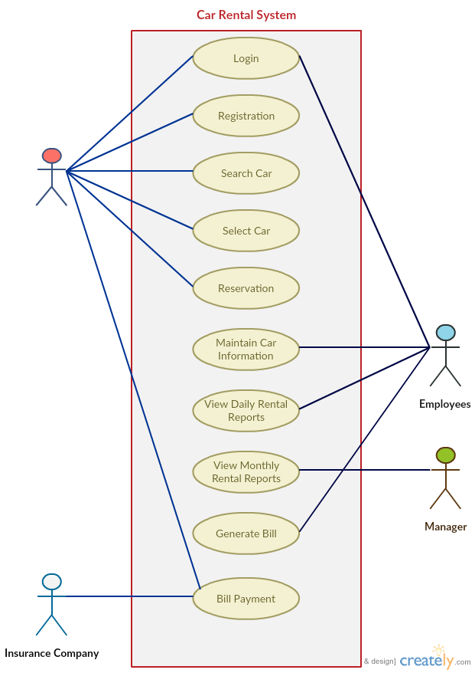

Figure 4.1: Use Case for Insurance Company

* 1. Use Cases Description

[Paragraph Text 12 pt, Times New Roman, 1.5 Line Spacing, Justified]

* + 1. User Login Function

Table 4.1: User Login Function 1

|  |  |
| --- | --- |
| **Title** | Allow user to sign in |
| **Requirement** | User must be registered through admin |
| **Rational** | Login to the system |
| **Restriction or Risk** | Wrong or correct login sent to database |
| **Dependency** | Pc, Internet connection |
| **Priority** | Safety, timing |

**Use case 1**

Table 4.2: User Login Function: UC1 1

|  |
| --- |
| **Login** |
| **Actor** |
| * Regular User |
| **Preconditions** |
| * Must be register through Admin |
| **Basic flow** |
| * User wants to sign in |
| **Alternate flows** |
| * User don’t want to view result |
| **Post Condition** |
| * User must Sign Out |

Similarly, students will create all the use cases along with diagrams and descriptions.

1. 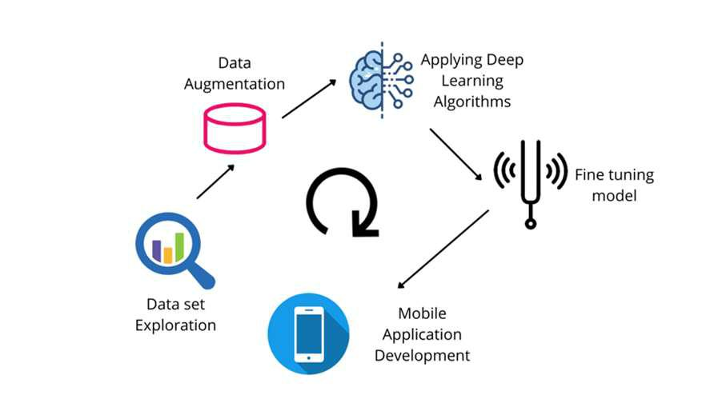Proposed Approach

Figure 5.1: Proposed Approach

* 1. Data Set Exploration

In this step, we explored our dataset and found the following limitations:

* Imbalanced data
* Inter-class similarities
* Intra-class variation
  1. Data Augmentation and Pre-Processing

In this step, we will try to solve issues in our dataset using data augmentation and different data pre-processing techniques.

***Explain all steps of proposed approach in this way***

1. Business Plan

[Paragraph Text 12 pt, Times New Roman, 1.5 Line Spacing, Justified]

[*Between 4 to 8 lines describe what is this chapter all about*]

## Business Description

[Paragraph Text 12 pt, Times New Roman, 1.5 Line Spacing, Justified]

## Market Analysis & Strategy

[Paragraph Text 12 pt, Times New Roman, 1.5 Line Spacing, Justified]

## Competitive Analysis

[Paragraph Text 12 pt, Times New Roman, 1.5 Line Spacing, Justified]

## Products/Services Description

[Paragraph Text 12 pt, Times New Roman, 1.5 Line Spacing, Justified]

## SWOT Analysis

[Paragraph Text 12 pt, Times New Roman, 1.5 Line Spacing, Justified]

# Appendix A: Information / Promotional Material

[Paragraph Text 12 pt, Times New Roman, 1.5 Line Spacing, Justified]

[*Between 4 to 8 lines describe what is this appendix all about*]

* 1. **Broacher (if any)**

* 1. **Flyer (if any)**
  2. **Standee (if any)**
  3. **Banner** **(if any)**

1. Conclusion

[Paragraph Text 12 pt, Times New Roman, 1.5 Line Spacing, Justified]

[*In max 2 pages please conclude your FYP*]

References

[1] A. Asghar, J. R. Wiles, and B. Alters, “The origin and evolution of life in Pakistani High School Biology,” J. Biol. Educ., vol. 44, no. 2, pp. 65–71, 2010.

[2] A. Bordes, N. Usunier, and L. Bottou, “Sequence Labelling SVMs Trained in One Pass,” in Proceedings of the 2008 European Conference on Machine Learning and Knowledge Discovery in Databases - Part I, Berlin, Heidelberg, 2008, pp. 146–161.

[3] M. Magrane, M. J. Martin, C. O’Donovan, and R. Apweiler, “Protein Sequence Databases,” in The Proteomics Protocols Handbook, J. M. Walker, Ed. Totowa, NJ: Humana Press, 2005, pp. 609–618.

[4] Y. Xu, J. Cui, and D. Puett, Cancer Bioinformatics, 2014 edition. New York: Springer, 2014.

[5] Author if any, Web Page Title, referenced: Month date, year.

This is the final page of a Fyp/Dissertation and should be a blank page

# Microsoft Word Tutorial - Remove These Page

* Turn on Word’s View/Navigation Pane – use this to move around the document outline. You can close or open subsections of this outline. Very convenient for editing a large document.
* Turn on Word’s *styles* pane (Alt-Ctrl-Shift-S) and at the bottom select *Options* and then select *Formatting in Use*. There are other options but this one indicates only a few formats are in use so far in this template.
  + Use style *Heading1* style for the title and *Heading2, Heading3*, ... for lower levels of section headings.
  + Generally, in most documents use the *Normal* style for almost all text paragraphs (though this fyp uses style *FypParagraph* style which is based on Normal) but indents every paragraph.  You can change individual paragraph spacing by right clicking and selecting *Paragraph* -or- change the overall general definition of any style by selecting the style in the Styles pane to the right and redefining some aspect (font, paragraph spacing, … associated with the style)
  + If you put the cursor in an area of text, you can see which style is used in that text. For instance, many fyp paragraphs use the *FypParagraph* style (which indents for you so you do not have to).
  + There are only so many formatting styles in use and many more *Available Styles* and you can define your own. Styles govern font size, bold, italic, line and paragraph spacing, etc. Do not get too fancy, simple is best. Avoid using intra and inter line spacing when you can use or modify styles. If you mess up by redefining a widely used style, use Undo. Do not go hog wild with styles (even though you are at UofA where going hog wild should be normal).  A document with fewer styles is better - avoid the gawdy and baroque.
  + It is sometimes useful to use the *Clear All* command (near the top of the pane) before applying or converting a document to a new style. Select an area of the document and click *Clear All* which turns the selected area to *Normal* style.
* Right click on the Table of Contents or the List of Figures to Update Field. These are created with the Refernces tab.
* Turning *View/Ruler* on is a good idea.  Learn to use tabs and tables.
* If working with someone else, use Word's revision mode (*Review* tab).  One person writes a document, another edits with revision mode turned on.  This allows the first person to review the changed document and spot the changes easily. Then they can accept or reject changes.
* Use Insert/Page Numbers to add page numbers to a document.  Bottom center is a good choice.  You can remove page numbers by selecting the footer and then the page number box and shift-delete.
* Use Page Layout/Breaks to insert page or section breaks.  A section allows you to change numbering or headers or footers between sections.  You can see your page breaks in Normal View instead of Page Layout View (below the left ruler).

# FYP DEFENSE

* Complete your forms well ahead of time: Fyp Title form, Advisory Committee, Fyp Committee. These forms are on the CSCE website under *(Under)Graduate/Advising*. Near the time of your fyp defense, double check that your title on the fyp is the same as the one you turned in on the form. If not, re-fill out the fyp titme form and get it to Susan Huskey. Also, request your committees availabibility around the time you need to defend and once you all agree on a time, then schedule a room for your defense (via Sue Huskey).
* Also double check with Susan Huskey about a Degree Check to make sure you have taken all the courses you need to. Also, you need to fill out a form for graduation.
* Work on your fyp while you work on the corresponding research. If you write a big program first but never ask youself where the research is, you may have trouble writing your fyp.
* Timing:
  + You need to defend your fyp and turn it in *one week before* [Dead Day](http://www.uark.edu/registrar/classes/calcover.html) – the day before finals.
  + You need to give your committee at least one week to review your fyp.
  + Your committee should not see your fyp until your advisor has read it and given you corrections. That takes about a week – unless there are a lot of changes, then it might take a few passes. So complete your draft fyp around week 12 of the semester.
  + Finally, do not depend on defending at the last minute – faculty travel, … build in some slack to you timeline.
  + Helpful hint: take a rough draft of your fyp (on normal paper) to the Grad School and ask them to review its format. Do this near the end before you print copies. They review and give you instructions on any format glitches. Tell me if they identify any so I can fix the template.
* Defense:
  + When your advisor approves your fyp, then you need to prepare a presentation (usually .ppt) for your committee for the oral defense of your fyp.
  + Your talk should be announced by Susan Huskey and guests (faculty, students, family, friends) are allowed to come. At least your committee will be there. Note: you will need to reserve a room for your defense – see Sue Huskey to schedule the room. Typically defending students bring snacks to appease the professors.
  + Your presentation should take 40 minutes or less. It should be 25-30 slides. Structurally, it can hug the fyp format. For instance
    - Slide1 – title of fyp, your name, degree you are aiming at (MS in Computer Science), your Committee. [at the defense you will be introduced by your advisor and you will say the fyp title and thank your committee for serving]
    - Slide2 – Outline – eg., bullets for Problem, Objective, Background, … Conclusions, Future Work. You won’t spend much time on this at the defense, at most one minute
    - Slide3 – Problem – try to keep this to one slide
    - Slide4 – Objective – one slide
    - … the Background is typically several slides
    - … the bulk of the presentation is the Architecture and Results
    - Conclusion
    - Future Work
    - Questions
  + Plan on completing your presentation several days before you defend and dry run it with your fyp advisor.
  + A day or two early, ask Sue Huskey to prepare paperwork for your defense. Also, send your committee email reminding them of the time and place of the defense. Bring to your defense four copies of your fyp signature page, one on the nice paper the grad school requires.

ADDITIONAL NOTES

* If you know it is not your best work, wait until you have done the work to get it in good shape before you give it to your advisor. This is your job. It is your job to do the level best you can and then it is your advisor’s job to help you improve it, make sure you are complete, clear, and it is well written. It does not go to your committee until it is ready for them to see it and your advisor has given the green light.
* The purpose of the committee is to provide other eyes. Every document gets better if you can get several people to review it. Remember this throughout your career.
* Take special care that your Abstract, Problem, Objective sections are especially clear and well stated.
* Fonts:
  + Try to avoid using many fonts, Times New Roman will do for a fyp.
  + Exception: Use “Code” style (Courier New font) for appendices or lines that contain code.
* Punctuation:
  + Note on punctuation: There is no space before a comma, semicolon, colon, or period. There is one space after a comma or semicolon and two spaces after a colon or period.
  + … word(word …) => … word (word …)
* Spell check your fyp
* Table of Contents – double check that each heading is indented the same amount and that all main words are capitalized. You can use the document map or fyp table of contents to make sure.
* Text:
  + Avoid “I” and “my”
  + Consider each word – can you remove the word or replace it with a stronger word and so improve the text
  + Almost always avoid “very” or similar adverbs. Also, avoid “etc” as that is telling the reader to fill our your thought which offends the reader.
* Avoid plagiarism. Short quotes in “…” and longer quotes indented, single spaced. See [How to avoid plagiarism](http://libinfo.uark.edu/webdocs/reference/ENGRavoidplagiarism.pdf).

1. This is an example footnote.